**The sales data of Amazon  database**

1. **What is the count of distinct cities in the dataset?** select distinct(city) from amazon_data.amazon;

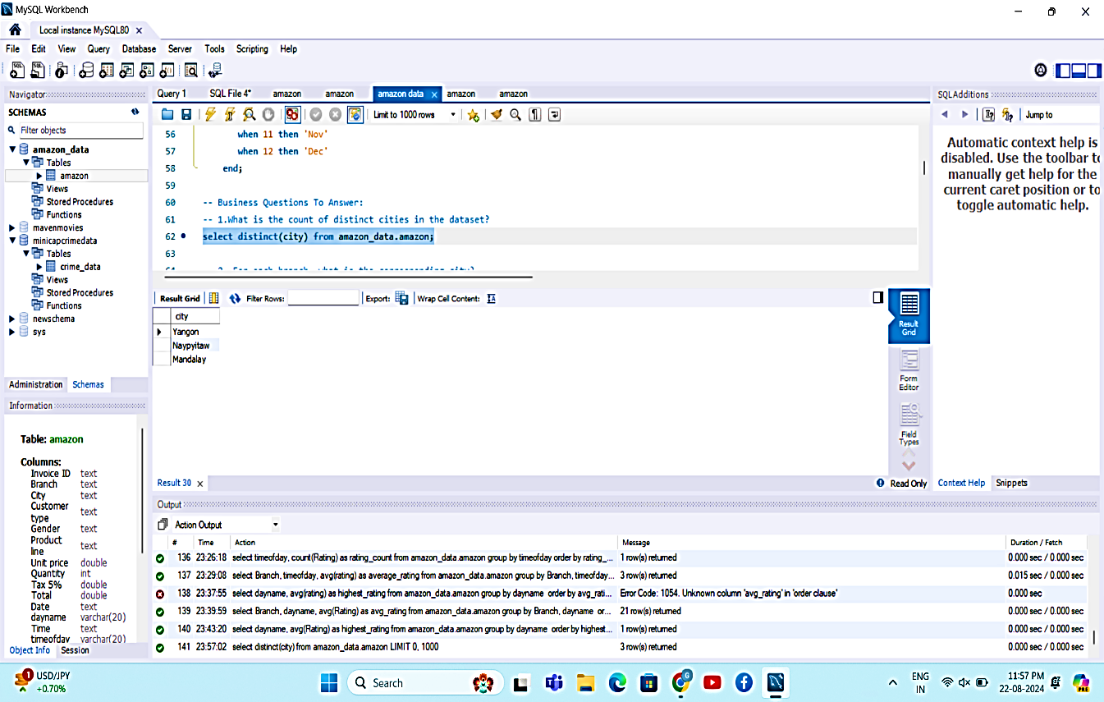

1. **For each branch, what is the corresponding city?** select distinct Branch,City from amazon_data.amazon;

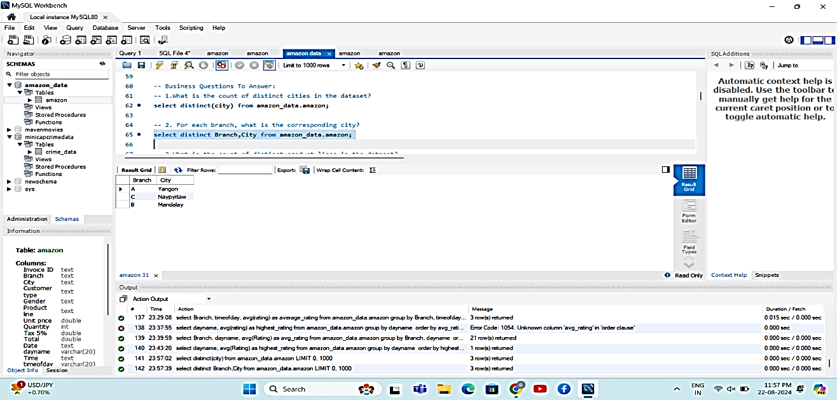

1. **What is the count of distinct product lines in the dataset?**  select count(distinct 'Product line') from amazon_data.amazon;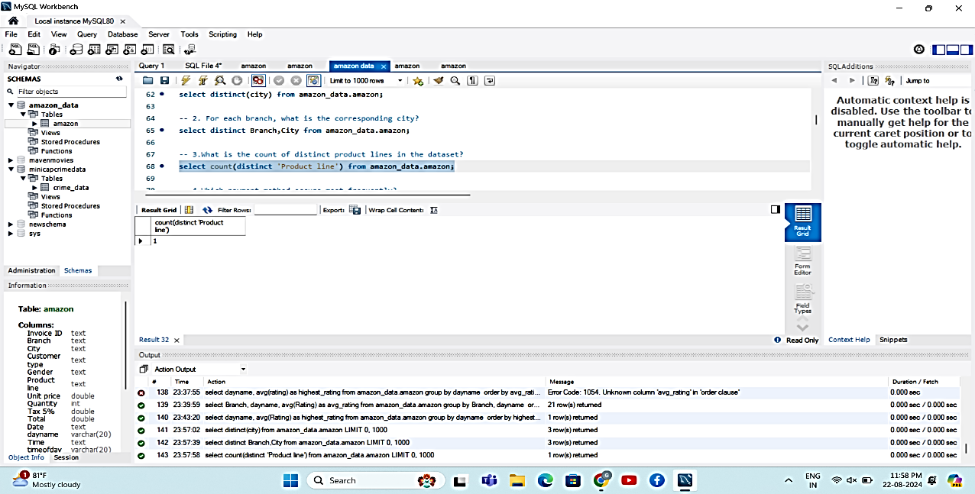
2. **Which payment method occurs most frequently?** 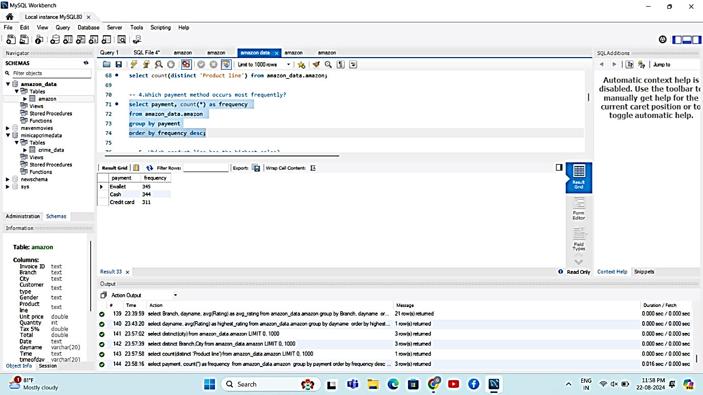
3. **Which product line has the highest sales?**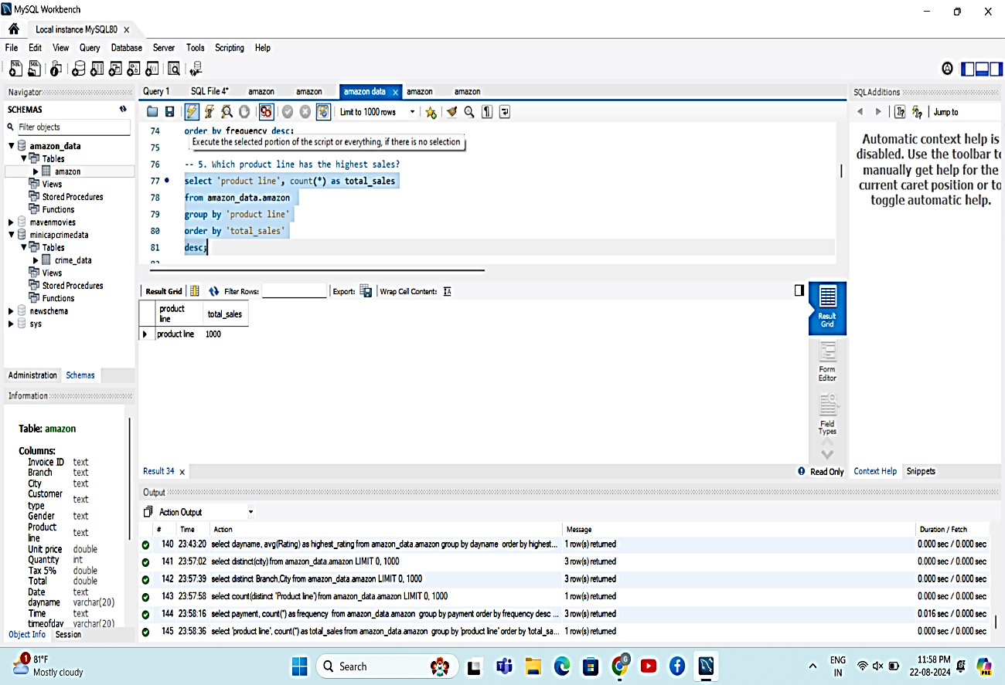
4. **How much revenue is generated each month?**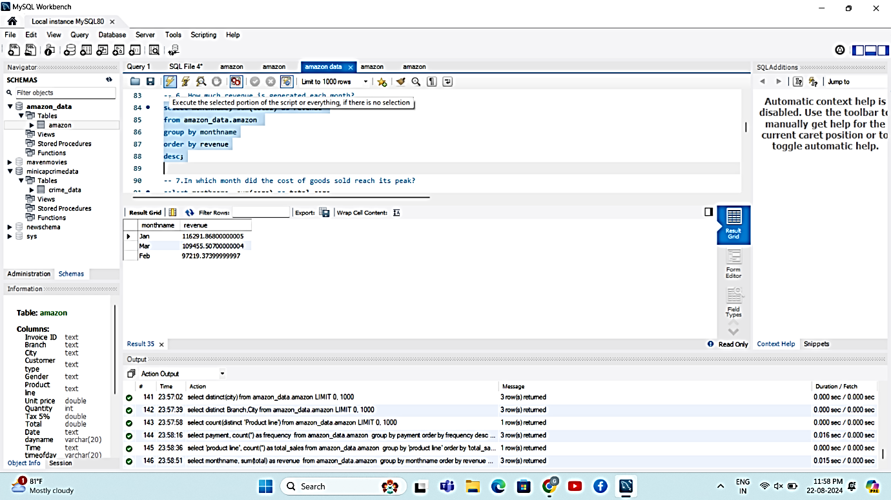
5. **In which month did the cost of goods sold reach its peak?**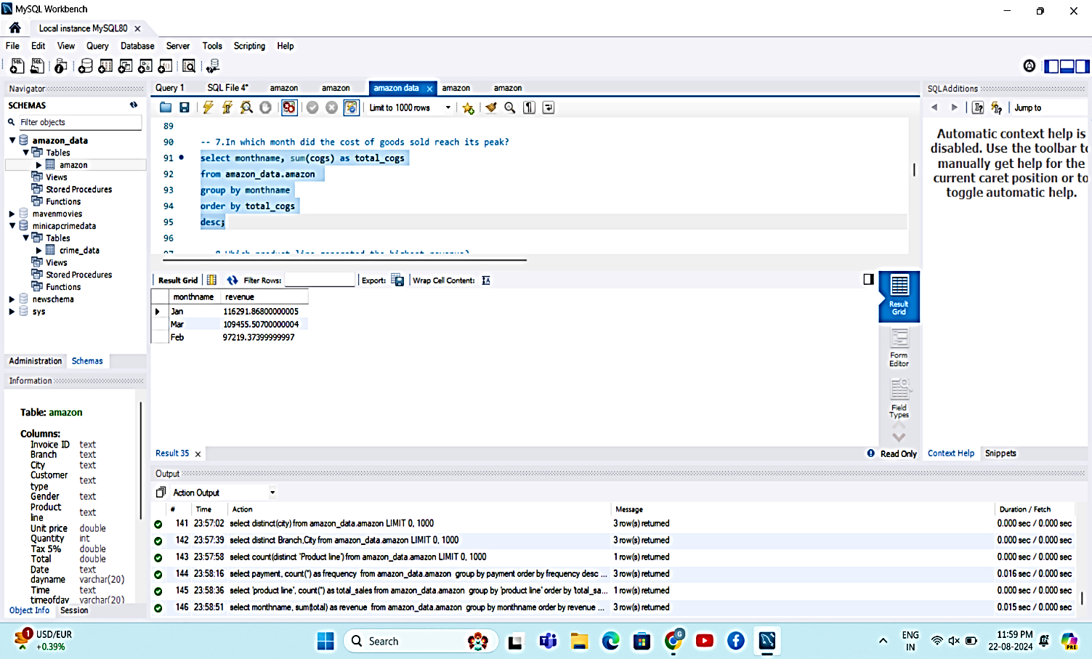
6. **Which product line generated the highest revenue?**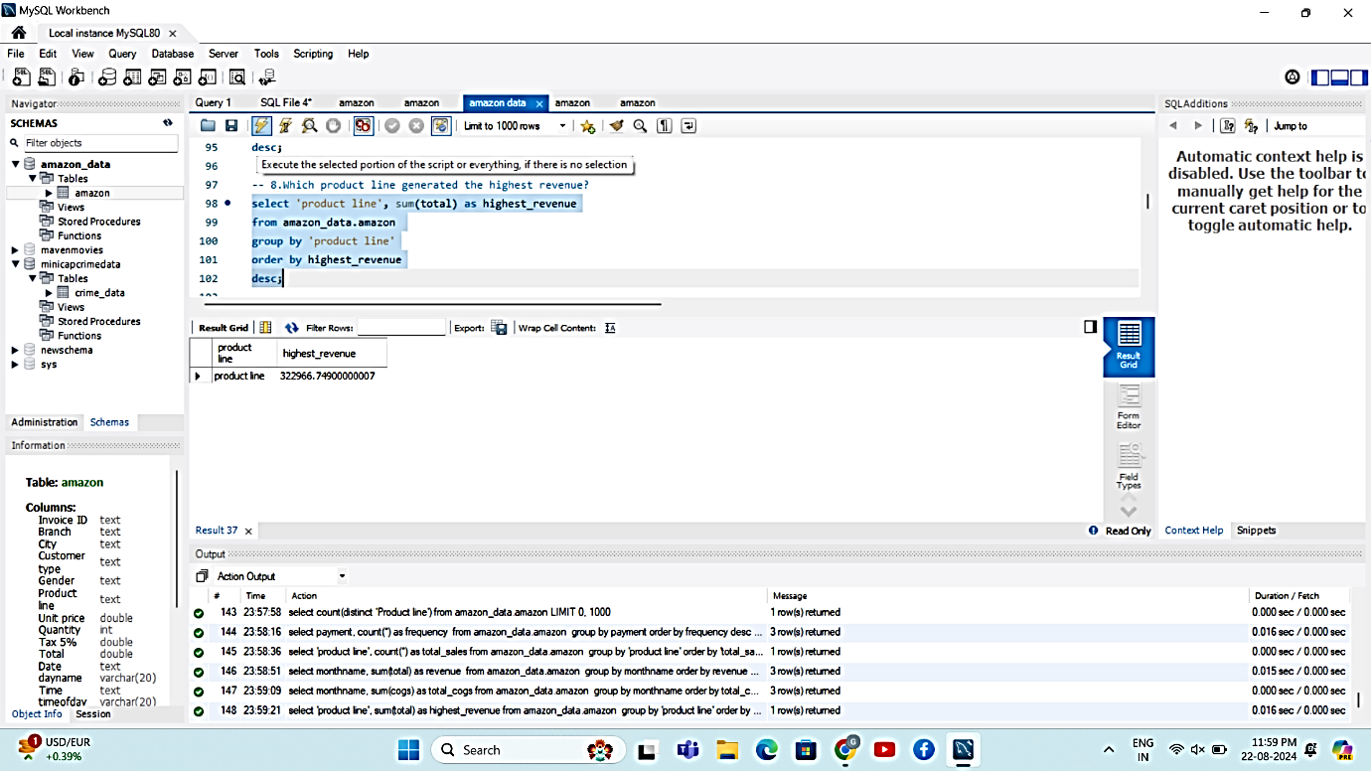
7. **In which city was the highest revenue recorded?**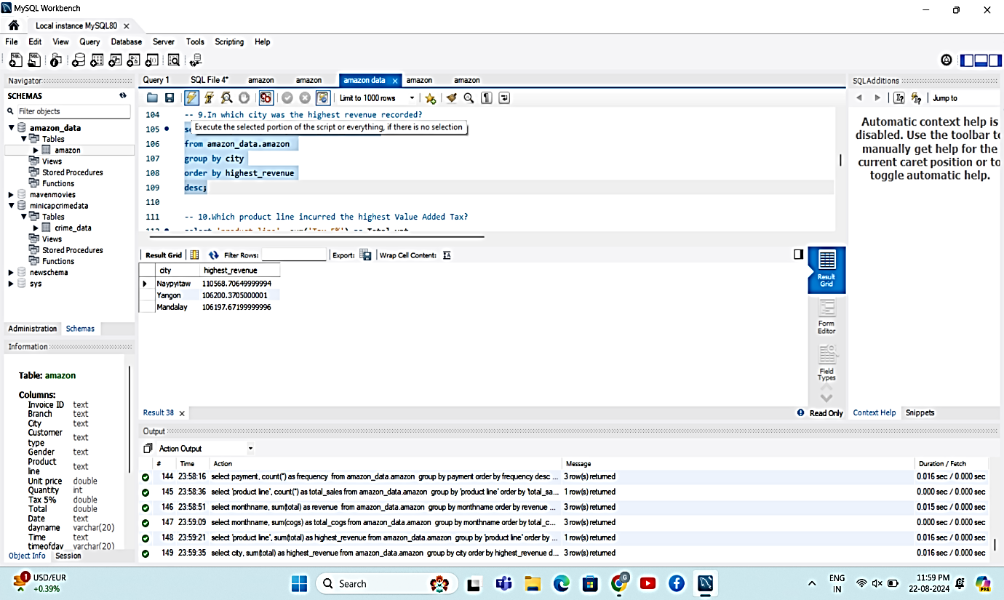
8. **Which product line incurred the highest Value Added Tax?**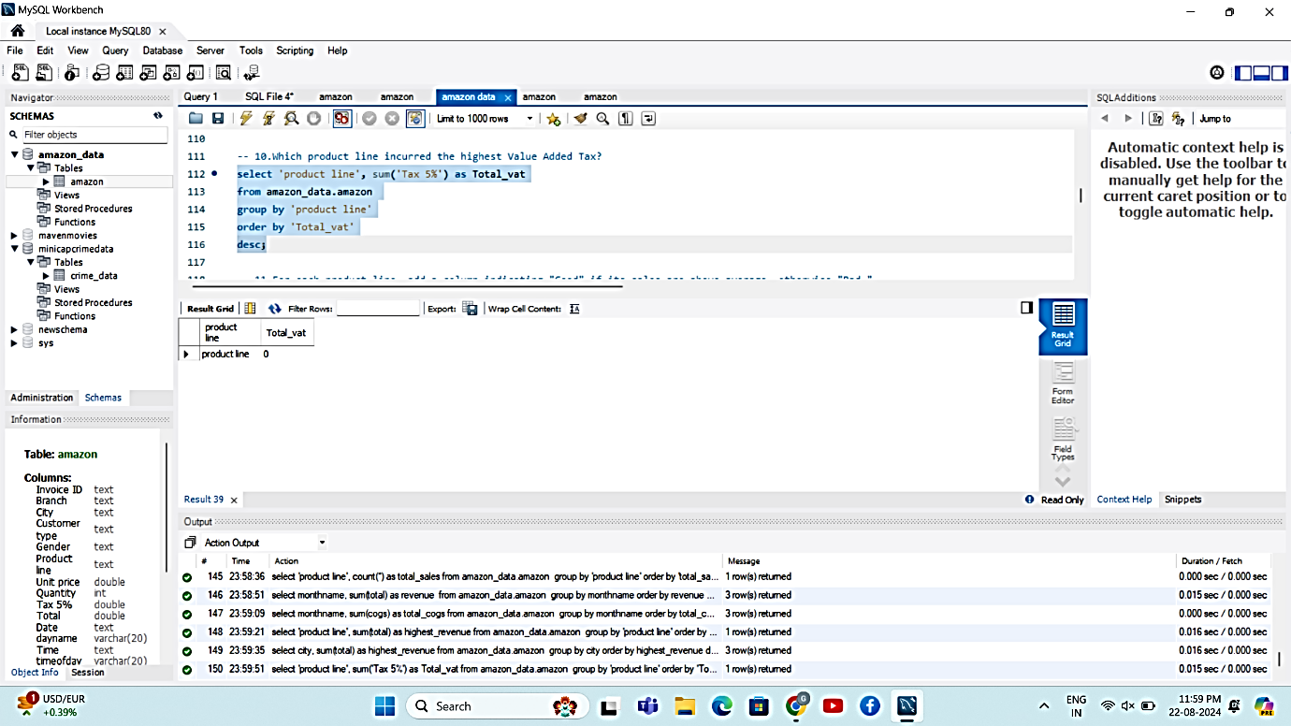
9. **For each product line, add a column indicating "Good" if its sales are above average, otherwise "Bad."**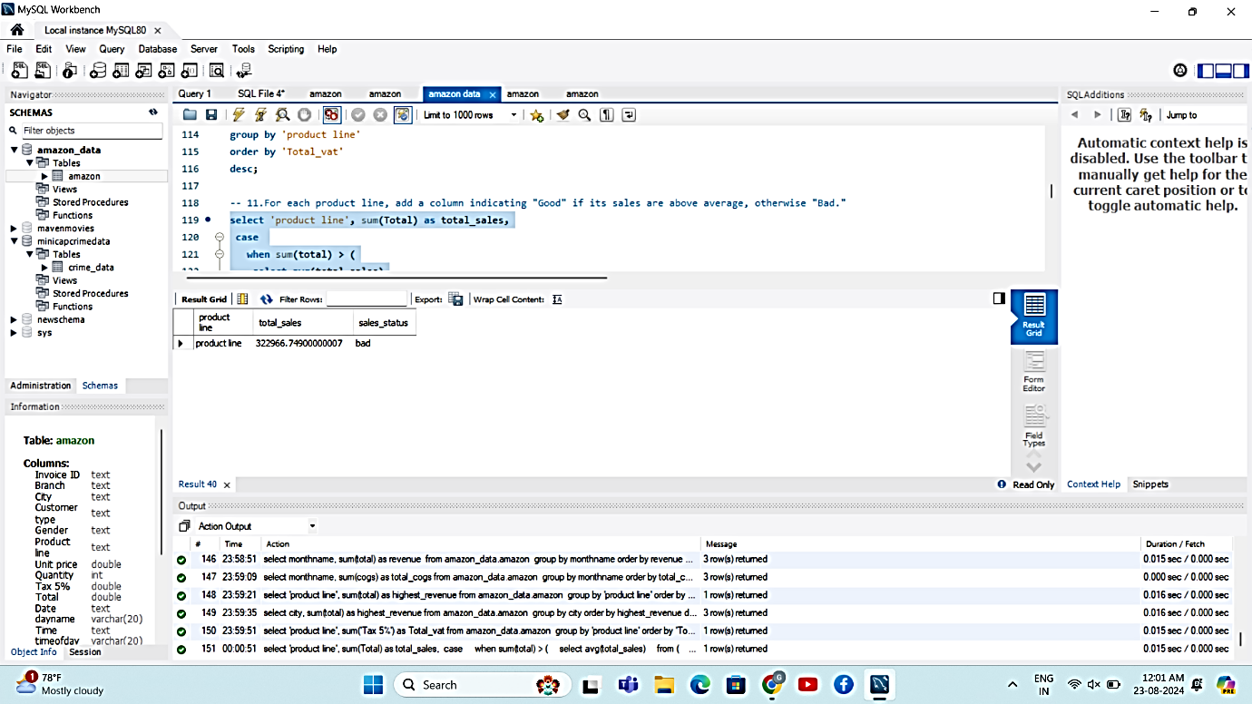
10. **Identify the branch that exceeded the average number of products sold.**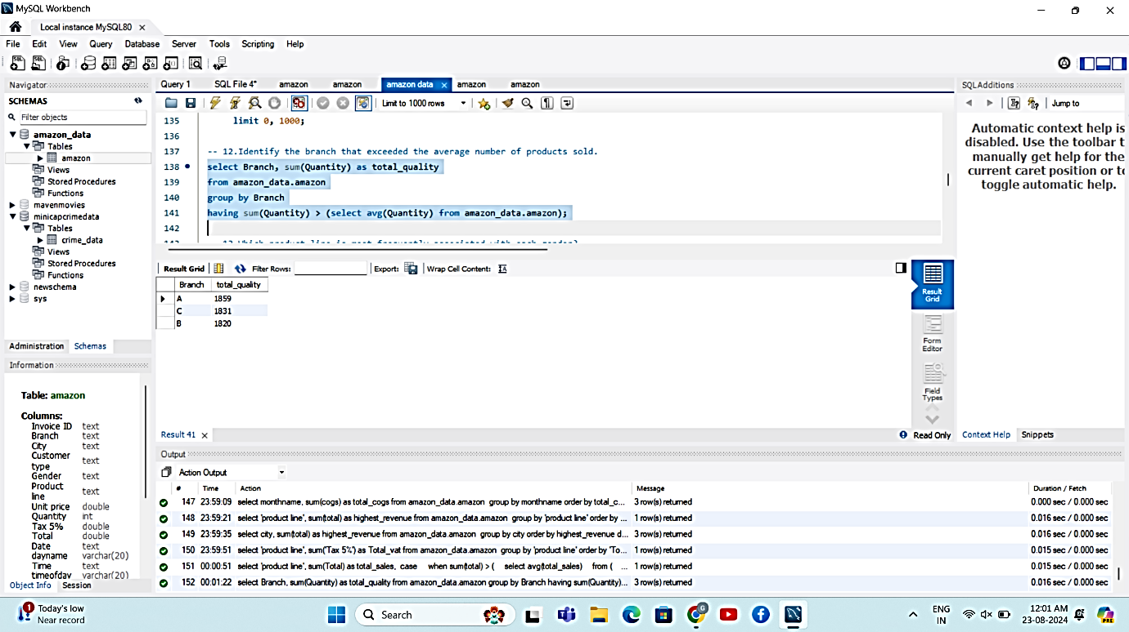
11. **Which product line is most frequently associated with each gender?**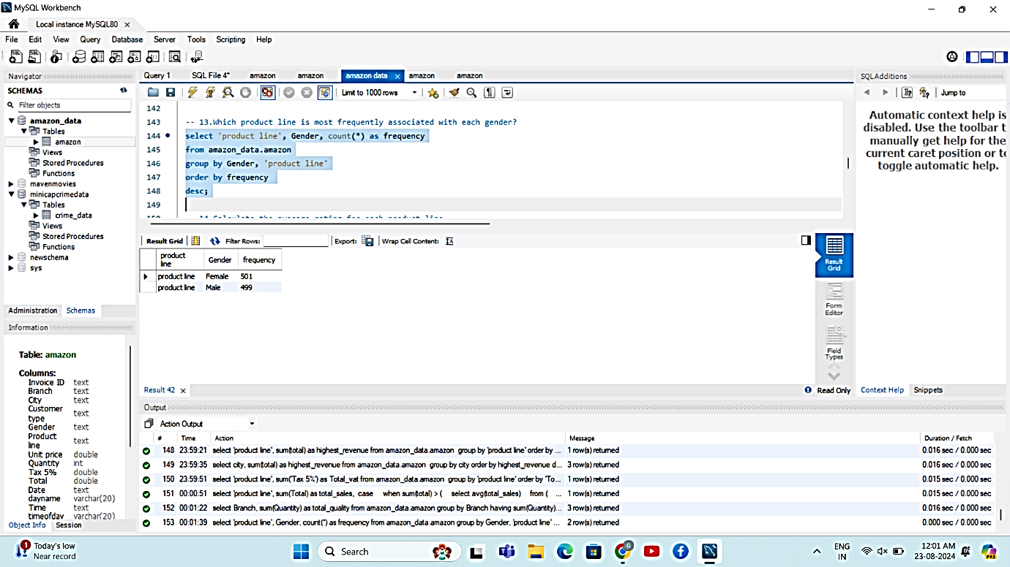
12. **Calculate the average rating for each product line.**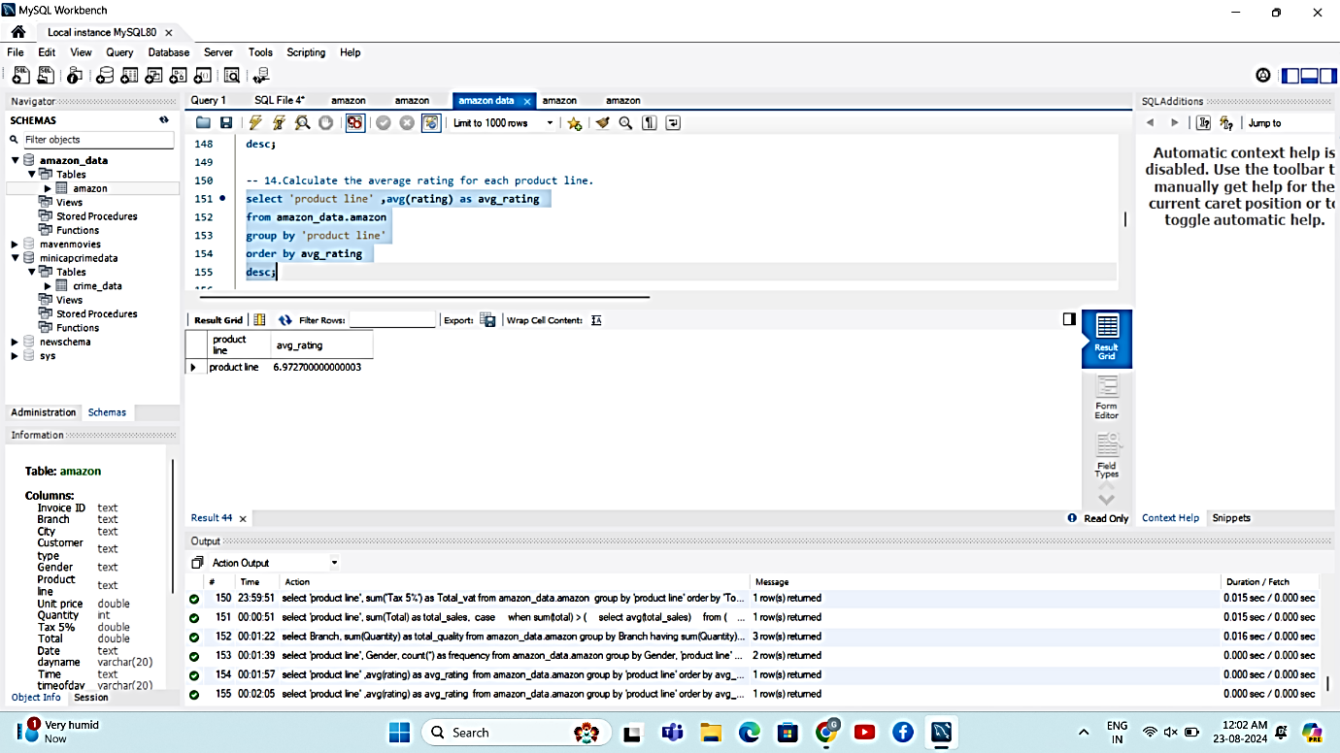
13. **Count the sales occurrences for each time of day on every weekday.**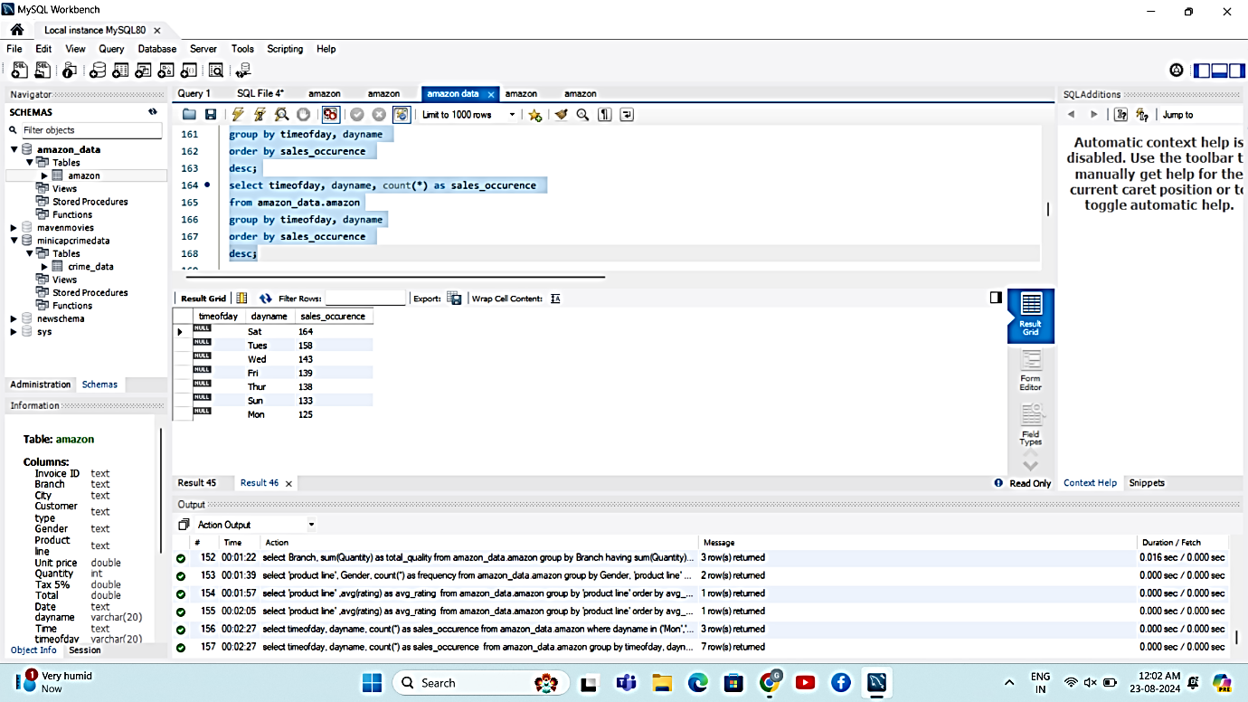
14. **Identify the customer type contributing the highest revenue.**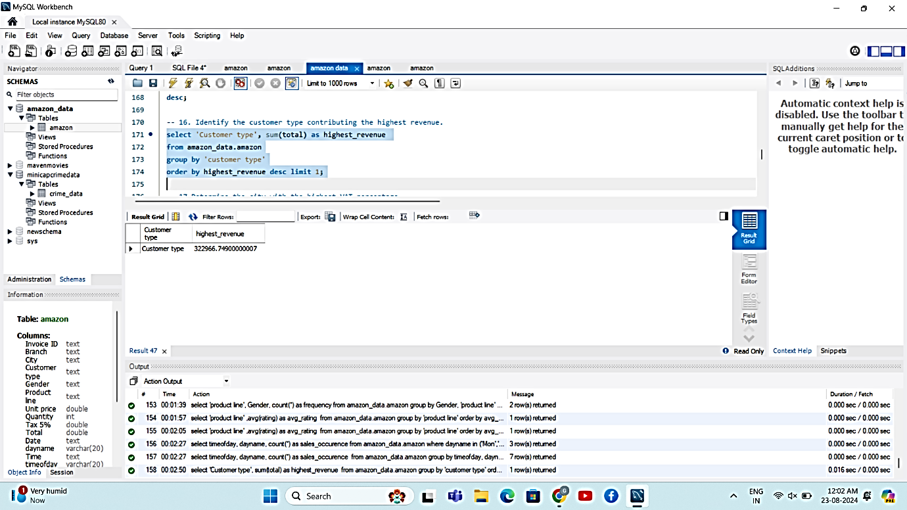
15. **Determine the city with the highest VAT percentage.**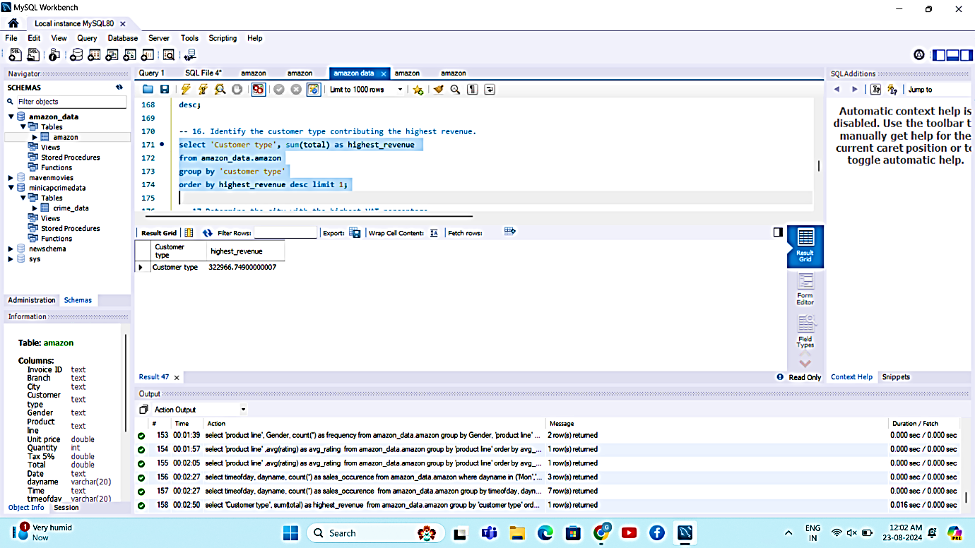
16. **Identify the customer type with the highest VAT payments.**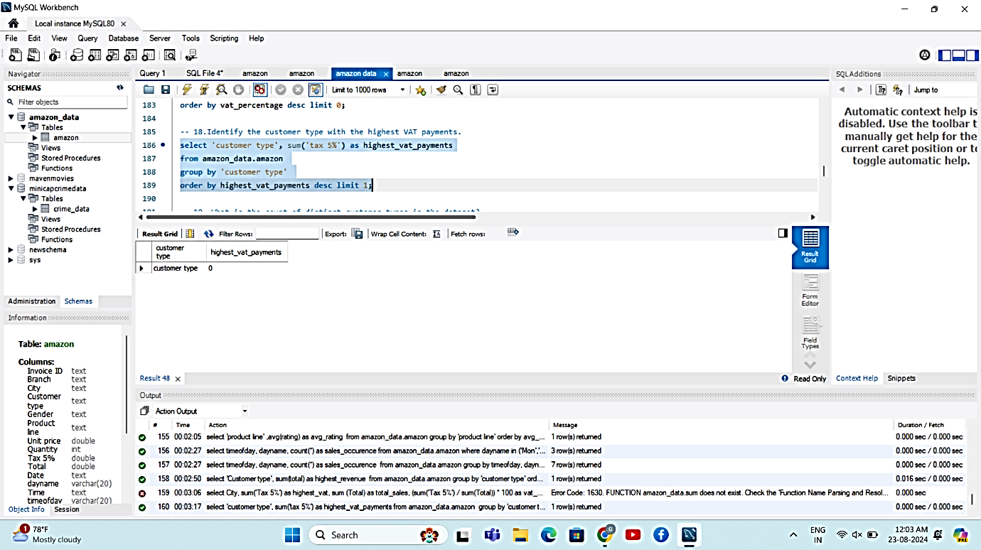
17. **What is the count of distinct customer types in the dataset?**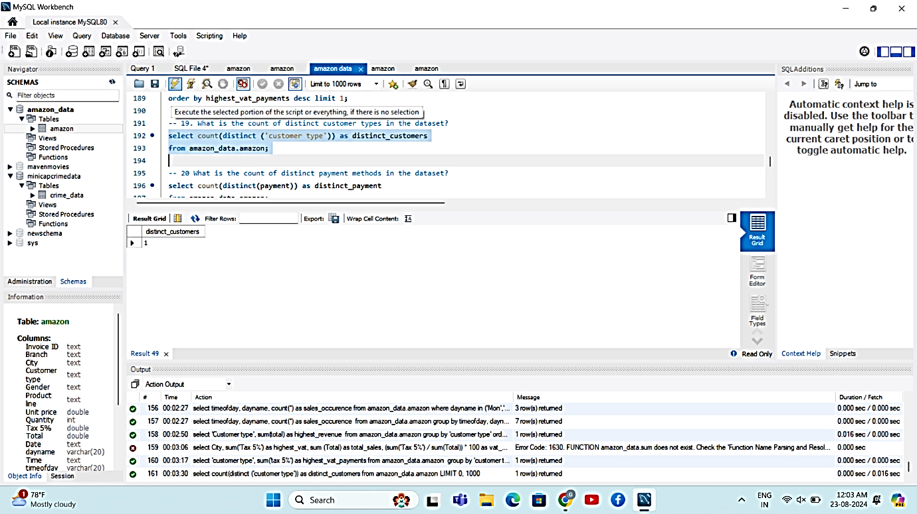
18. **What is the count of distinct payment methods in the dataset?**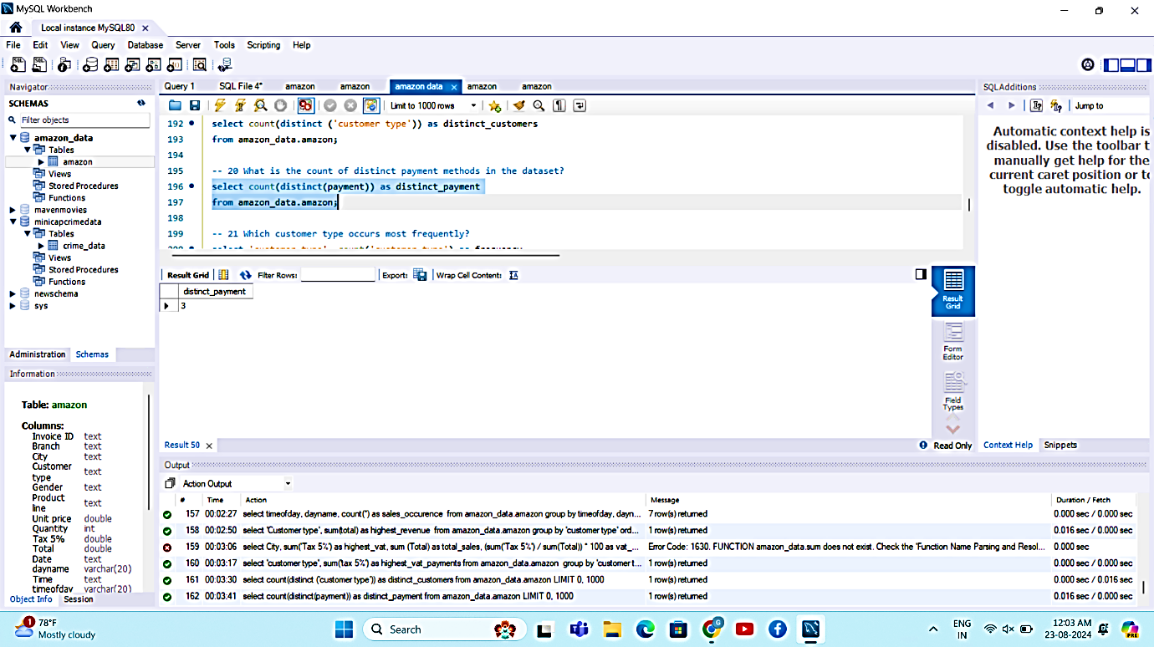
19. **Which customer type occurs most frequently?**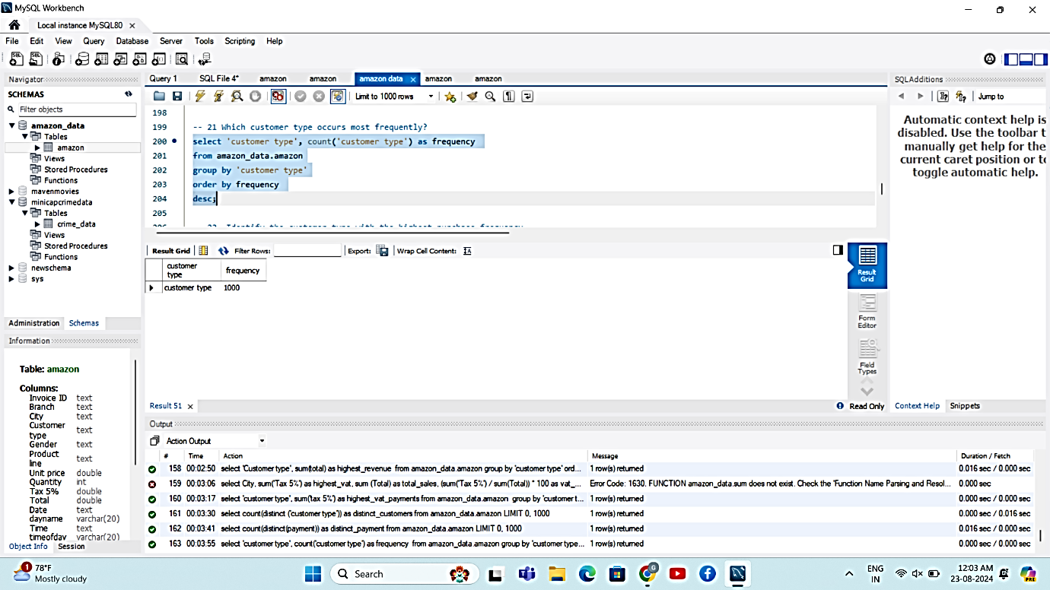
20. **Identify the customer type with the highest purchase frequency.**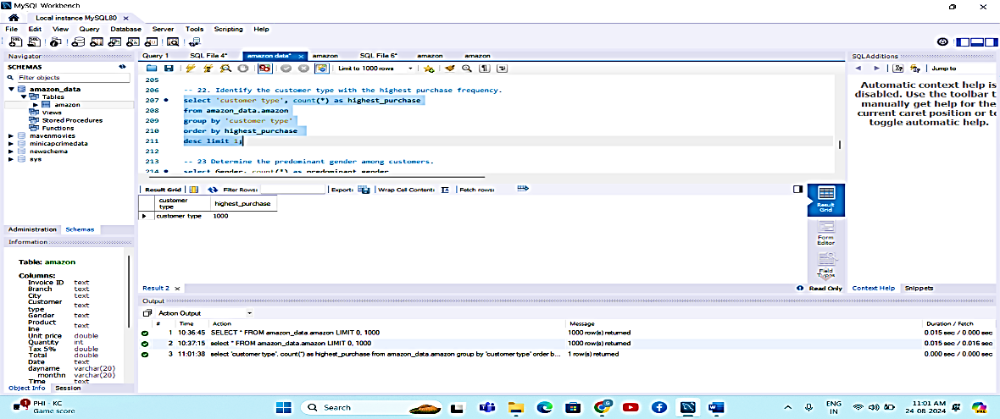
21. **Determine the predominant gender among customers.**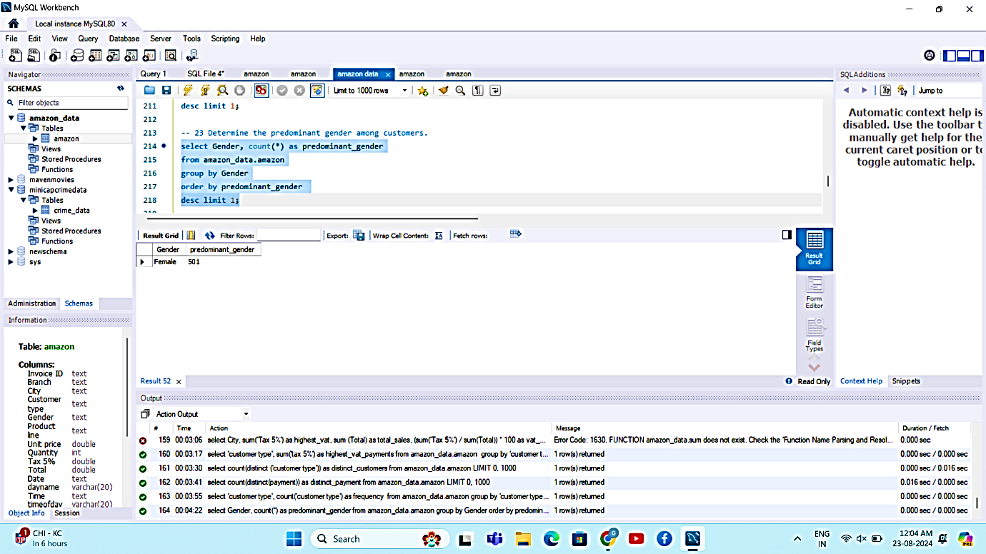
22. **Examine the distribution of genders within each branch.**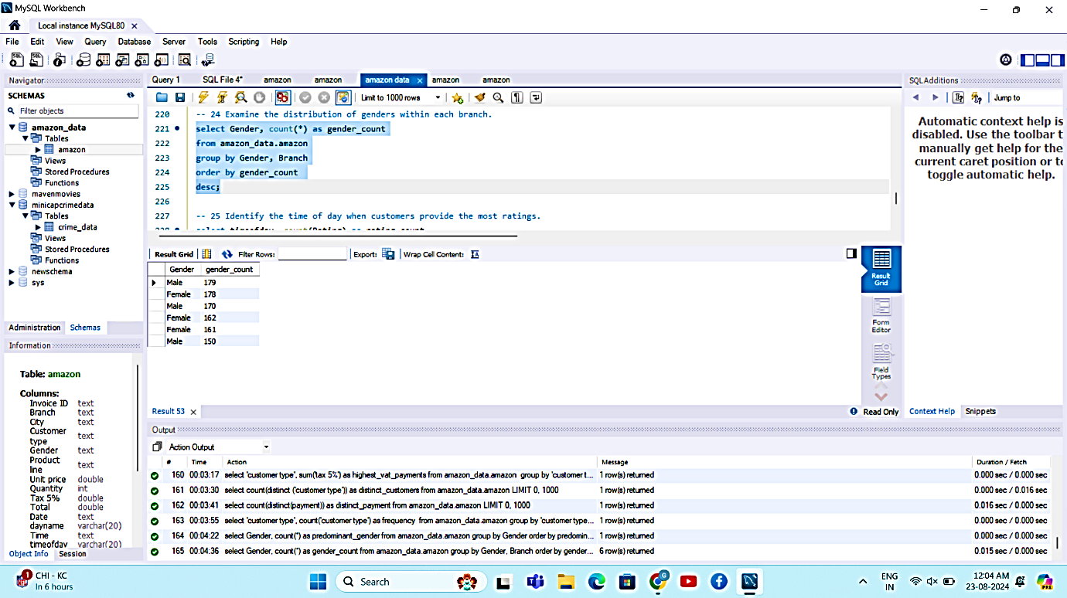
23. **Identify the time of day when customers provide the most ratings.**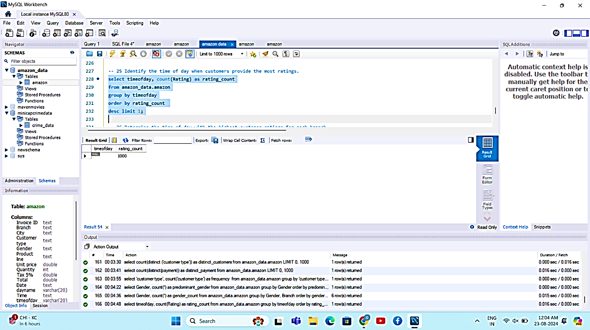
24. **Determine the time of day with the highest customer ratings for each branch.**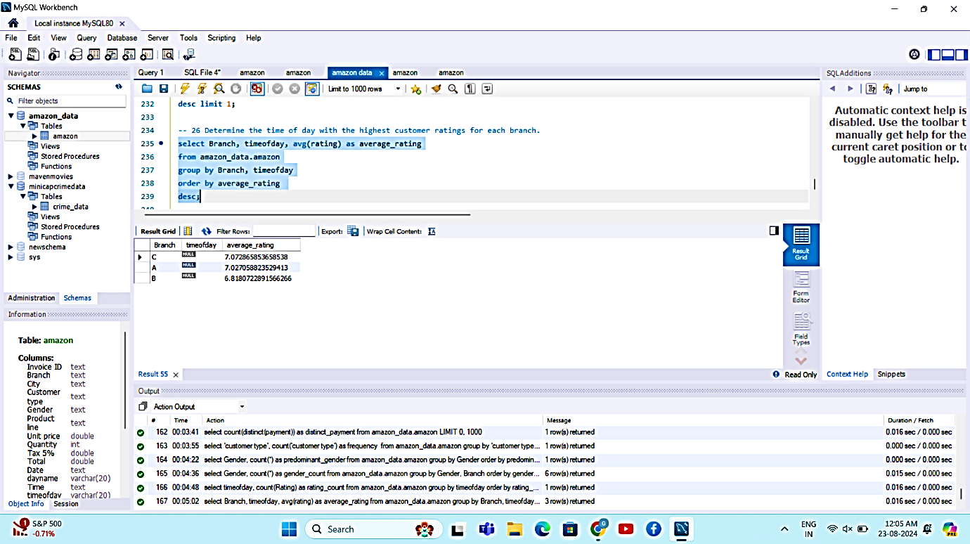
25. **Identify the day of the week with the highest average ratings.**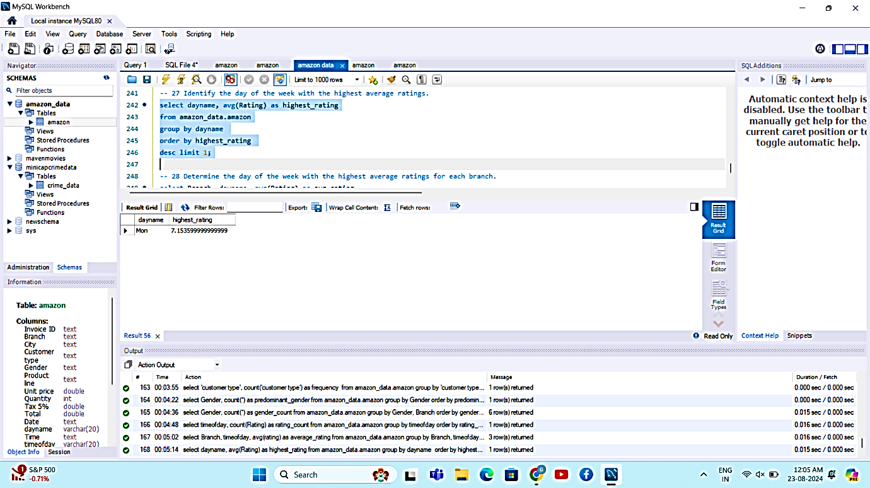
26. **Determine the day of the week with the highest average ratings for each branch.**

